T

Authentication and Authorization System Requirements & Design

Product Suite | TIBCO BusinessEvents
Product | TIBCO BusinessEvents
Product Version | 5.1
Initial Author | Aditya Athalye

Copyright Notice
COPYRIGHT© 2008-2009 TIBCO Software Inc. This document is unpublished and the foregoing notice is affixed to protect TIBCO Software Inc. in the event of inadvertent publication. All rights reserved. No part of this document may be reproduced in any form, including photocopying or transmission electronically to any computer, without prior written consent of TIBCO Software Inc. The information contained in this document is confidential and proprietary to TIBCO Software Inc. and may not be used or disclosed except as expressly authorized in writing by TIBCO Software Inc. Copyright protection includes material generated from our software programs displayed on the screen, such as icons, screen displays, and the like.
Trademarks
Technologies described herein are either covered by existing patents or patent applications are in progress. All brand and product names are trademarks or registered trademarks of their respective holders and are hereby acknowledged.
Confidentiality
The information in this document is subject to change without notice. This document contains information that is confidential and proprietary to TIBCO Software Inc. and may not be copied, published, or disclosed to others, or used for any purposes other than review, without written authorization of an officer of TIBCO Software Inc. Submission of this document does not represent a commitment to implement any portion of this specification in the products of the submitters.
Content Warranty
The information in this document is subject to change without notice. THIS DOCUMENT IS PROVIDED "AS IS" AND TIBCO MAKES NO WARRANTY, EXPRESS, IMPLIED, OR STATUTORY, INCLUDING BUT NOT LIMITED TO ALL WARRANTIES OF MERCHANTABILITY OR FITNESS FOR A PARTICULAR PURPOSE. TIBCO Software Inc. shall not be liable for errors contained herein or for incidental or consequential damages in connection with the furnishing, performance or use of this material.
For more information, please contact:
TIBCO Software Inc.
3303 Hillview Avenue
Palo Alto, CA 94304
USA

Change Log 4
Related Documents 4
1 Introduction 5
Purpose 5
Scope 5
Audience 5
References 5
2 Acronyms and Vocabulary 6
3 Motivation 7
4 Use Case 8
5 Functional Requirements 9
5.1.1 Authentication System : 9
5.1.2 Authorization System : 9
6 Design 9
6.1.1 Approach : 9
6.1.2 Component Diagram: 10
6.1.3 Authentication Flow : 11
6.1.4 Authorization Flow : 12
6.1.5 Authorization-Policy-Representation : 13
6.1.6 Authorization-Policy-Deployment : 14
6.1.7 User-Lifecycle-Management : 15

Change Log
.
Date | Version | Name | Description
4/12/11 | 0.1 | Aditya Athalye | Initial Document Creation
4/12/11 | 0.2 | Aditya Athalye | Few indentation changes and some requirements added.
4/13/11 | 0.3 | Aditya Athalye | Added more functional requirements based on questions from Anand.

Related Documents
Document Title | Revision Number | Author
Authen/Authz design doc.

Introduction

Purpose
The purpose of this document is to outline an approach for doing authentication and authorization in a consistent manner across all components of Business Events.

Scope
Functional requirements of the new BusinessEvents Authentication and Authorization System. (Henceforth BAAS).
Design and implementation constraints if any.

Audience
Developers
Architects
Quality Assurance

References

Acronyms and Vocabulary

The table below describes some of the Acronyms used in this documentation
- BE – TIBCO BusinessEvents.
- EAR - Enterprise Archive
- SAR - Shared Resource Archive
- BAR - BusinessEvent Archive
- Cluster
- Agent
- Deployment
- CDD – Cluster Deployment Descriptor
- MM – Monitoring and Management.
- RMS – Rules Management Server.
- WS – BE Webstudio.
- BAAS – BusinessEvents Authentication and Authorization System.

Motivation
Authentication and Authorization are a near must in every enterprise application when one or more users belonging to various groups/roles in the organization interact with it.
BusinessEvents is no exception to this rule, and it has components like RMS, BE-Views, MM facilitate user interaction in a manner which necessitates verification of authentic users. All of these components allow users to interact with them insofar as providing view access to something, or invocation of certain operation, or execution of CRUD operations on resource(s) managed by them and so on.
This mandates that the users who interact with these components firstly log in to the system so that only genuine users can do any of the operations any of these components exposes, and also they get to do operations that they have permissions for. This ensures that there is no unauthorized access to any of these operations and system security is not jeopardized in any way.
Now if every component tries to build its own mechanism for doing AAS, then there is no consistency across the product, and hence the document aims to outline an approach which all components will be able to follow and also make it a scalable feature so that any future requirements could be catered to as well.

Use Case
A schematic use case which presents a bird’s eye view of all subsystems involved is shown here.
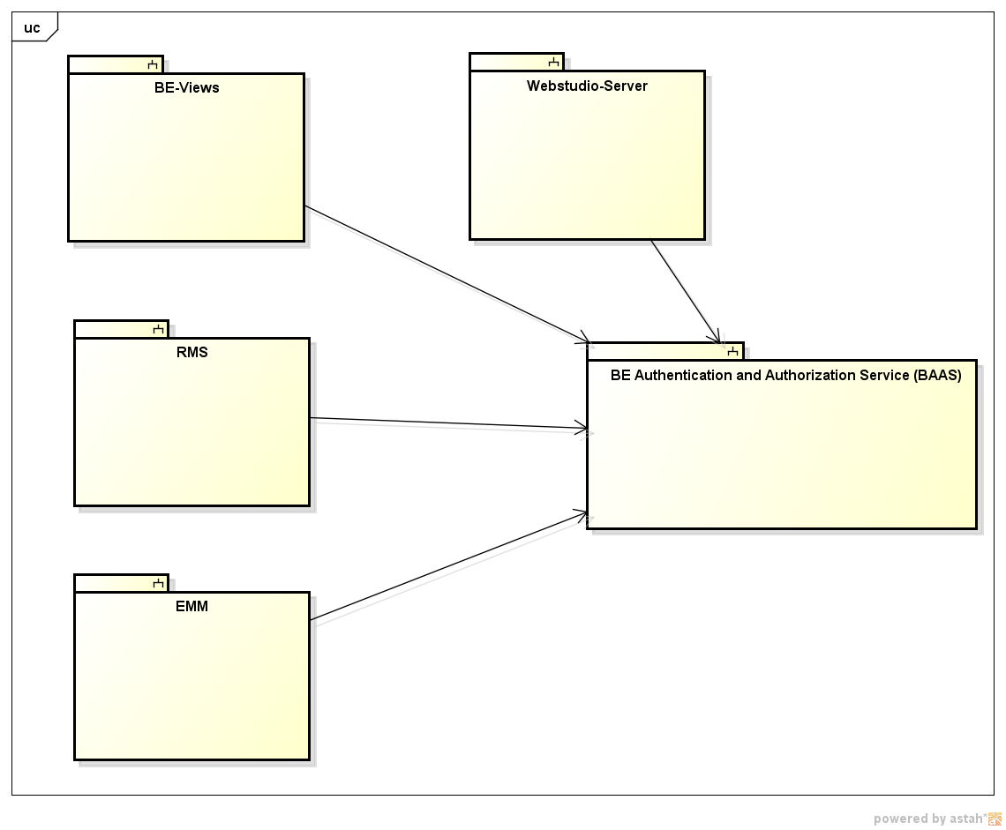
As can be seen from the diagram, the RMS, BEViews, EMM, WS-Server subsystems will interact with the BAAS for their authentication and authorization needs.

Functional Requirements

Authentication System :

- Support unified and consistent authentication to all BE components.
- Support user session management.
- Support Single Sign On : If a user has logged in to the system via certain credentials, through one component he should not be authenticated again from other component unless the user’s session has expired.
- Automated Fail Over Support (Nice to Have).
- Support different modes of username/password authentication: e.g : Digest authen (Nice to Have).

Authorization System :

- Support centralized authorization to all BE components.
- Enforce Role Based Access control where each role either gets to do a certain operation or is denied.
- Provide easy to use specification of access control policies for various components. This should be done only by specified roles which BAAS would be configured for.
- Provide consistent format for specification of access policy irrespective of the component.
- Users belonging to more than one roles get a union of permissions for those roles.
- Provide hot deployment for policy changes.
- Support for selective role based permission checks (Views).
- Handle bulk permission checks to avoid lot of granular network calls.
- Support for subject based ACL granularity. (e.g : role A accesses only first 10 rows of a metric while row B accesses next 10).

Design

Approach :
BAAS is viewed as per this approach as a service which can be accessed by one and all components of BusinessEvents. Such a service is also developed as a BE project which leverages capabilities provided by the BE platform. There are many advantages of making this service a BE application:
- BE provides capabilities like Fault Tolerance/Load Balancing which will eventually be required by BAAS.
- BE provides out of the box support for object management using in built OM so that the BAAS service need not worry about writing code for writing internal data to DB and such.
- Out of Box support for state management which would be essential for BAAS (user lifecycle as a state machine, or authorization policy workflow if desired).
- In built support for NIO based HTTP channel which means transport layer for BAAS is taken care of.
Following diagrams illustrate various aspects of design:

Component Diagram:

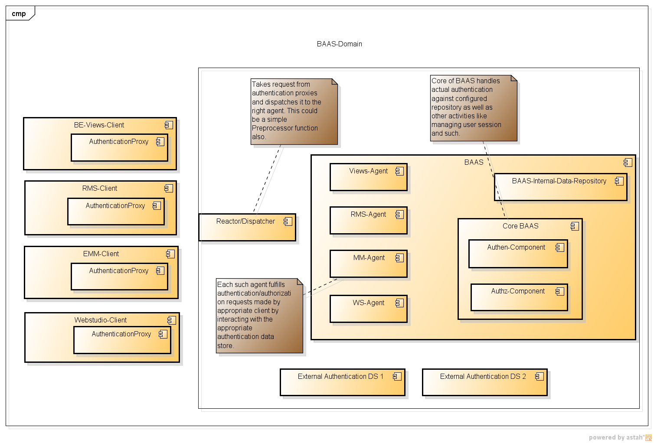
As can be seen from the diagram above the BAAS system encompasses the following components:
Dispatcher Service : A dispatcher (dispatcher as a pre-processor in BE language) which relays an incoming request to appropriate Agent.
Views-Agent : A component (can be visualized as a PU or Inference agent or simply rulesets) which will handle authentication requests coming from BE-Views client.
RMS-Agent : Similar to above except the client being RMS.
MM-Agent : Handle MM AAS requests.
WS-Agent : ..
BAAS Core Services : Handle actual authentication/authorization and data store interacation.
BAAS-Authen-Component : Perform authentication as well as user life-cycle management.
BAAS-Authz-Component : Perform authorization checks for requests made by any of the agents for permissions requested for any resource. Will use login information created by the Authen component.
BAAS-Internal-DataStore : The cache which maintains user session, and everything BAAS requires for functioning and internal book-keeping. This can be optionally backed by a Backing Store.

The motivation behind visualization of the AAS as a collection of components is that authentication configuration can be made separately for each agent so that if any component needs any special requirements for authen/authz, they can be taken care of (e.g : MM MBean ops). If not, the core BAAS settings can be used. (Remains to be seen how we allow users to configure this)

Authentication Flow :
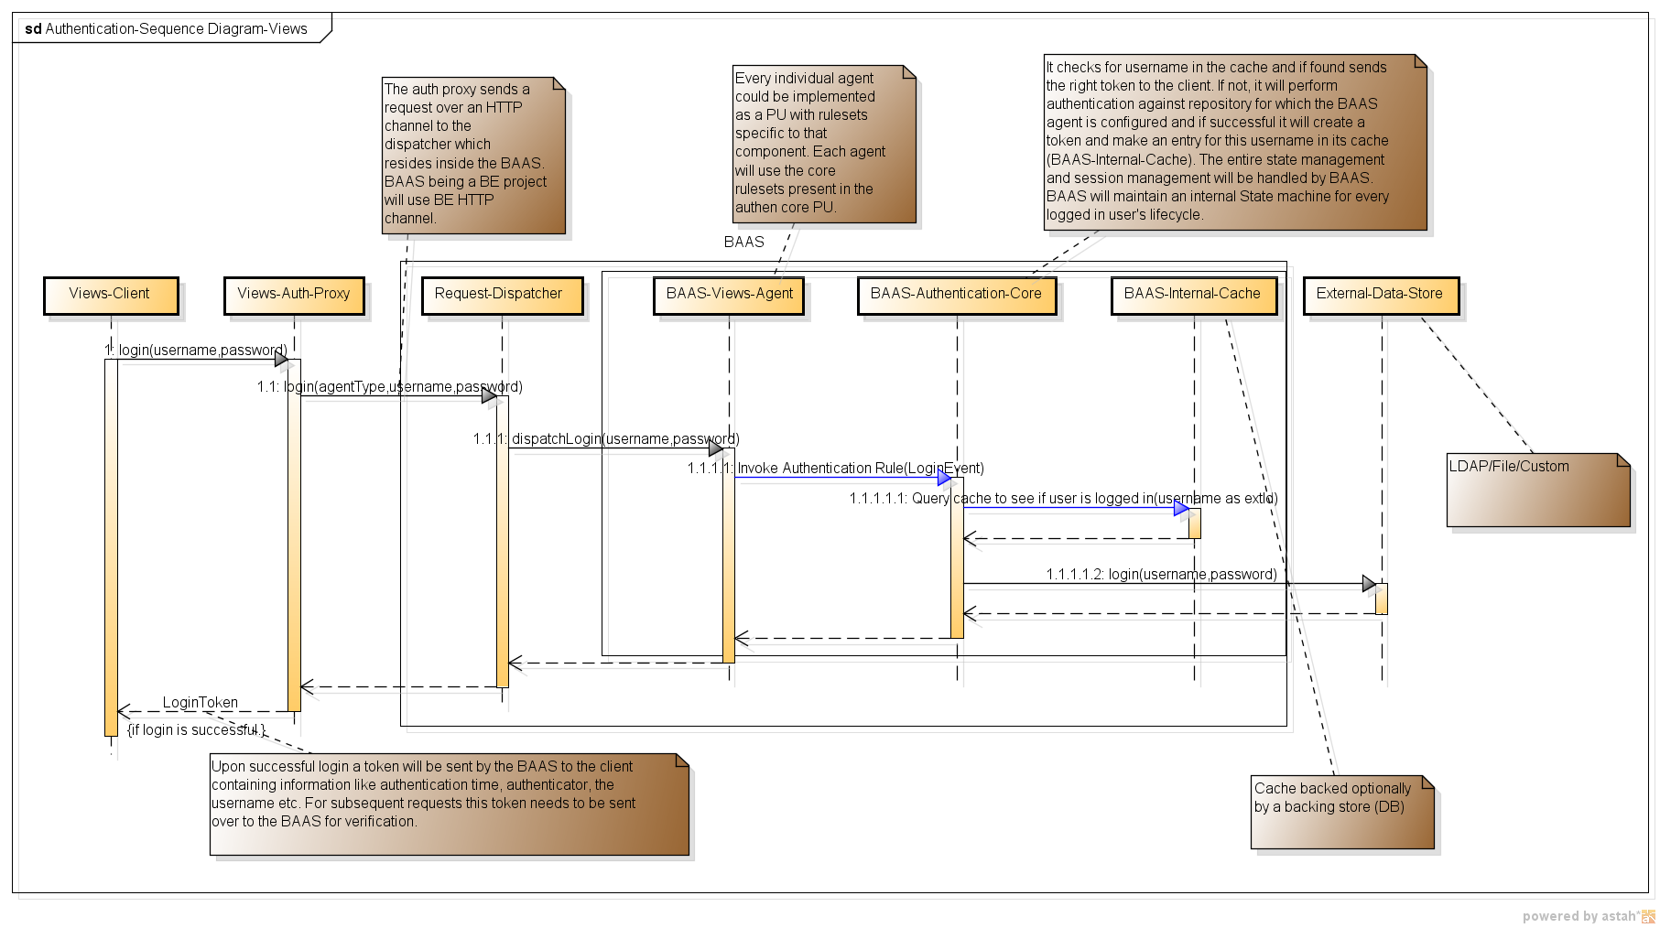
The diagram shows high level flow of an authentication request with Views as an example. Finer details are added as notes to get a better understanding.

Authorization Flow :
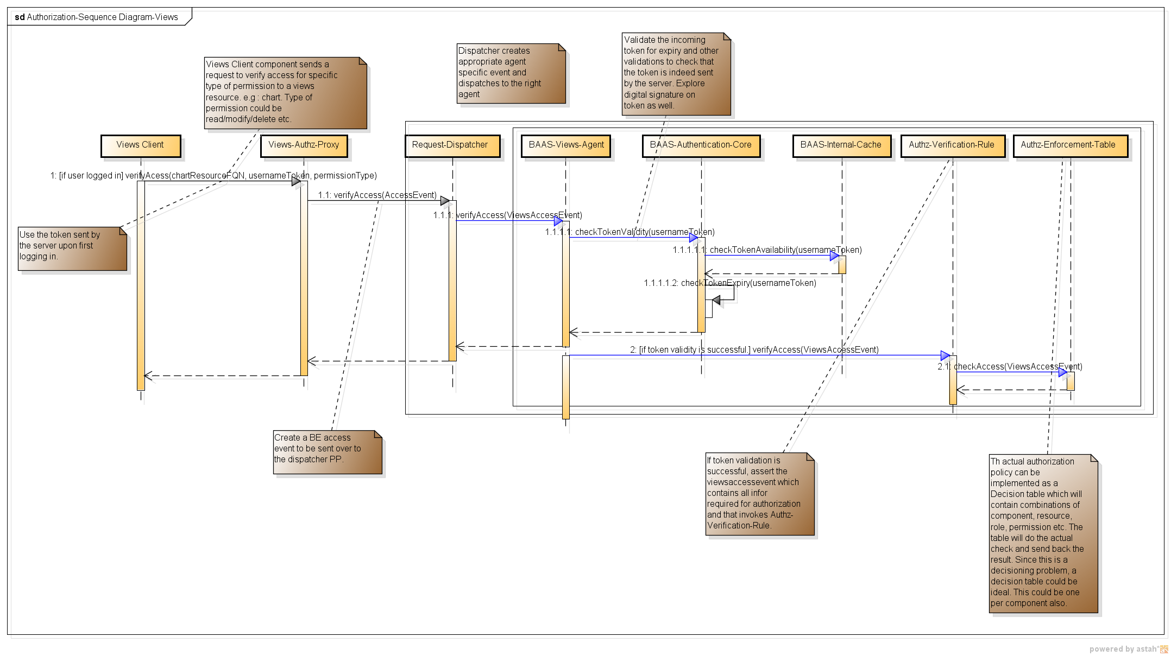

Authorization-Policy-Representation :

Authorization is essentially a decisioning problem and since this approach proposes to make BAAS as a BE project, it makes Decision Tables (DT) ideal for specification of permissions.
A sample format for specifying authz policy:
Component© | Resource© | ResourceType© | Role© | Permission© | Access(A)
MM | MBean1/Op1 | Mbean Operation | MM_ADMIN | View | Allow
MM | MBean1/Op1 | Mbean Operation | MM_USER | View | Deny
Views | * | * | BUSINESS_USER | Create | Deny
Views | * | Chart | VIEWS_ADMIN | Create | Allow
Views | /Folder/Metric1 | Metric | BUSINESS_USER | View | Deny
RMS | /Concept/Concept | Concept | BUSINESS_USER | View | Deny
RMS | TestProject | Project | BUSINESS_USER | Checkout | Allow
RMS | TestProject/Folder | Folder | BUSINESS_USER | Commit | Deny

This is only a sample but should be good enough to illustrate how permissions can be specified. © is conditions in the table and (A) is action.
There are multiple advantages of using Decision Table for specification of authorization policy/policies:
  - Decision Tables are easy to use and more naturally reflect a decision to be made like authorization where based on certain conditions one decides whether access for a role is given or not.
  - The BE DT route is a tried and tested implementation and tailor made for such use cases.
  - DT allows for combinatorial explosions without making the table in itself look very complex which will be quite useful for authorization case where granular permissions may be required for a large project.
  - Developing an authorization framework from scratch would require lot of development time and effort and importantly it means a new syntax has to be learnt by users. In contrast a Decision table would be very simple to use.
  - DTs can be very easily hot deployed into the system and this is also a tried and tested approach which means our turn-around time for the development of this system will be greatly reduced.
  - DT execution is optimized so performance will be good too.
Cons :
Minimalistic form of DTs need to be packaged. Is that possible (BE Express?)

Authorization-Policy-Deployment :

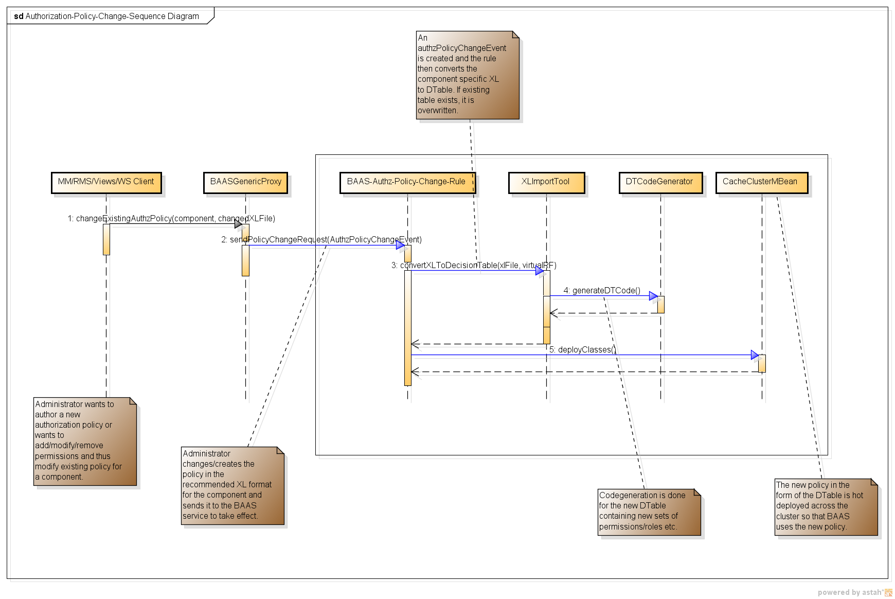
There are various options available for authoring these policies:
- XL based policy specification : A format like one above is specified so that users can add/modify/permissions easily. Once this is done, the changed policy document is sent over to BAAS for deployment so that future authorization decisions will use this. (Such a file can be specified per component as well.) The above diagram illustrates how this deployment can be done.
- A UI (web/desktop) where users can specify permissions and then send them over to BAAS. The flip side of this is again development time for such a UI will be more.
- Directly allow DT access : BAAS being a BE project, this source can be shipped over so that DTs can be authored/modified by admins themselves when they want to add new roles/modify permissions etc. This is the quickest way but it means exposing some of the internals of BAAS as well.

Domain models can be used by BAAS very effectively. Components can be defined as domain models e.g :
DM_Components :
- MM
- RMS
- Views
- Webstudio.

DM_Permissions : We can have such a domain model for each component type to decide what types of permissions it may need. E.g : MM may need only “View”, RMS may need “CRUD”.
DM_Action : Allow, Deny.

User-Lifecycle-Management :

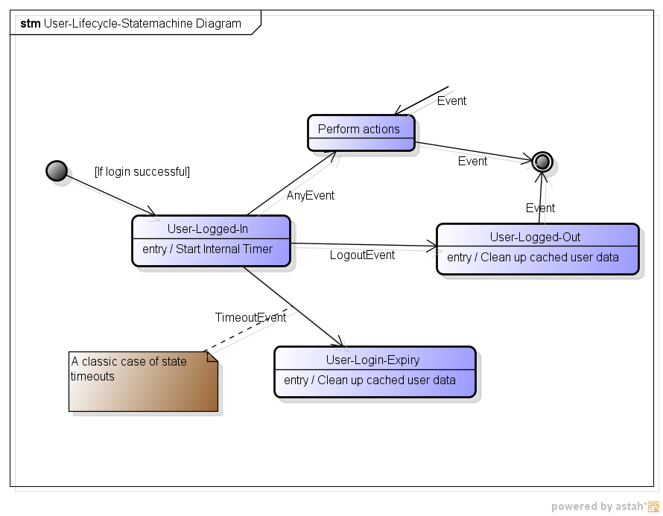
This shows a simple state machine depicting various states logged in user could go through, user expiry, logout and such. The big benefit of using BE to author BAAS is in built State Machine support along with state timeouts which can be used in conjunction with inactivity to expire user session.

